T. SAI SATHWIK

BATCH – 04

2303A51221

AI ASSISTED CODING

|  |  |  |  |  |  |  |  |  |  |
| --- | --- | --- | --- | --- | --- | --- | --- | --- | --- |
| **SCHOOL OF COMPUTER SCIENCE AND ARTIFICIAL INTELLIGENCE** | | | | | **DEPARTMENT OF COMPUTER SCIENCE ENGINEERING** | | | | |
| **Program Name:** B. Tech | | | | **Assignment Type: Lab** | | | **Academic Year:**2025-2026 | | |
| **Course Coordinator Name** | | | | Dr. Rishabh Mittal | | | | | |
| **Instructor(s) Name** | | | | |  | | --- | | Mr. S Naresh Kumar | | Ms. B. Swathi | | Dr. Sasanko Shekhar Gantayat | | Mr. Md Sallauddin | | Dr. Mathivanan | | Mr. Y Srikanth | | Ms. N Shilpa | | Dr. Rishabh Mittal (Coordinator) | | Dr. R. Prashant Kumar | | Mr. Ankushavali MD | | Mr. B Viswanath | | Ms. Sujitha Reddy | | Ms. A. Anitha | | Ms. M.Madhuri | | Ms. Katherashala Swetha | | Ms. Velpula sumalatha | | Mr. Bingi Raju | | | | | | |
| **CourseCode** | | | 23CS002PC304 | **Course Title** | | AI Assisted Coding | | | |
| **Year/Sem** | | | III/II | **Regulation** | | R23 | | | |
| **Date and Day**  **of Assignment** | | | **Week1 - Friday** | **Time(s)** | | 23CSBTB01 To 23CSBTB52 | | | |
| **Duration** | | | 2 Hours | **Applicable to**  **Batches** | | All batches | | | |
| **Assignment Number:1.3**(Present assignment number)/**24**(Total number of assignments) | | | | | | | | | |
|  | | | | | | | | | |
|  | **Q.No.** | **Question** | | | | | | ***Expected Time***  ***to complete*** |  |
|  | 1 | Lab 1: Environment Setup – *GitHub Copilot and VS Code Integration + Understanding AI-assisted Coding Workflow*  **Lab Objectives:**   * To install and configure GitHub Copilot in Visual Studio Code. * To explore AI-assisted code generation using GitHub Copilot. * To analyze the accuracy and effectiveness of Copilot's code suggestions. * To understand prompt-based programming using comments and code context   **Lab Outcomes (LOs):**  After completing this lab, students will be able to:   * Set up GitHub Copilot in VS Code successfully. * Use inline comments and context to generate code with Copilot. * Evaluate AI-generated code for correctness and readability. * Compare code suggestions based on different prompts and programming styles.   Task 0   * Install and configure GitHub Copilot in VS Code. Take screenshots of each step.   Expected Output   * Install and configure GitHub Copilot in VS Code. Take screenshots of each step.   Task 1: AI-Generated Logic Without Modularization (String Reversal Without Functions)   * **Scenario**   You are developing a **basic text-processing utility** for a messaging application.   * **Task Description**   Use GitHub Copilot to generate a Python program that:   * + Reverses a given string   + Accepts user input   + Implements the logic directly in the main code   + Does not use any user-defined functions * **Expected Output**   + Correct reversed string   + Screenshots showing Copilot-generated code suggestions   + Sample inputs and outputs   Task 2: Efficiency & Logic Optimization (Readability Improvement)   * **Scenario**   The code will be reviewed by other developers.   * **Task Description**   Examine the Copilot-generated code from **Task 1** and improve it by:   * + Removing unnecessary variables   + Simplifying loop or indexing logic   + Improving readability   + Use Copilot prompts like:     - *“Simplify this string reversal code”*     - *“Improve readability and efficiency”*   Hint: Prompt Copilot with phrases like *“optimize this code”*, *“simplify logic”*, or *“make it more readable”*   * **Expected Output**   + Original and optimized code versions   + Explanation of how the improvements reduce time complexity   Task 3: Modular Design Using AI Assistance (String Reversal Using Functions)   * **Scenario**   The string reversal logic is needed in **multiple parts** of an application.   * **Task Description**   Use GitHub Copilot to generate a function-based Python program that:   * + Uses a user-defined function to reverse a string   + Returns the reversed string   + Includes meaningful comments (AI-assisted) * **Expected Output**   + Correct function-based implementation   + Screenshots documenting Copilot’s function generation   + Sample test cases and outputs   Task 4: Comparative Analysis – Procedural vs Modular Approach (With vs Without Functions)   * **Scenario**   You are asked to justify design choices during a code review.   * **Task Description**   Compare the Copilot-generated programs:   * + Without functions (Task 1)   + With functions (Task 3)   Analyze them based on:   * + Code clarity   + Reusability   + Debugging ease   + Suitability for large-scale applications * **Expected Output**   Comparison table or short analytical report  Task 5: AI-Generated Iterative vs Recursive Fibonacci Approaches (Different Algorithmic Approaches to String Reversal)   * **Scenario**   Your mentor wants to evaluate how AI handles **alternative logic paths**.   * **Task Description**   Prompt GitHub Copilot to generate:   * + A **loop-based** string reversal approach   + A **built-in / slicing-based** string reversal approach * **Expected Output**   + Two correct implementations   + Comparison discussing:     - Execution flow     - Time complexity     - Performance for large inputs     - When each approach is appropriate   **Note: Report should be submitted as a word document for all tasks in a single document with prompts, comments & code explanation, and output and if required, screenshots.** | | | | | | Week1 - Monday |  |

TASK-1

PROMPT:

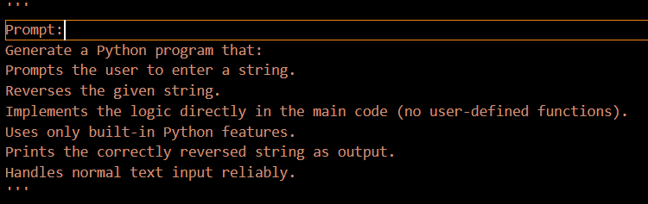

CODE:

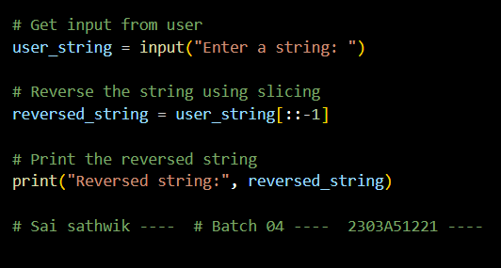

OUTPUT:

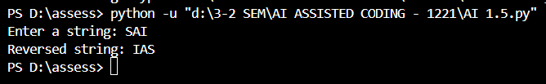

JUSTIFICATION:

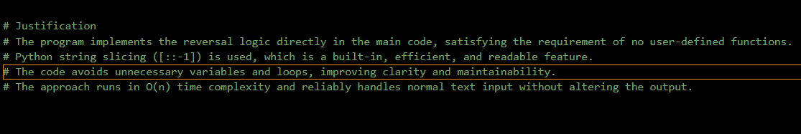

TASK2:

PROMPT

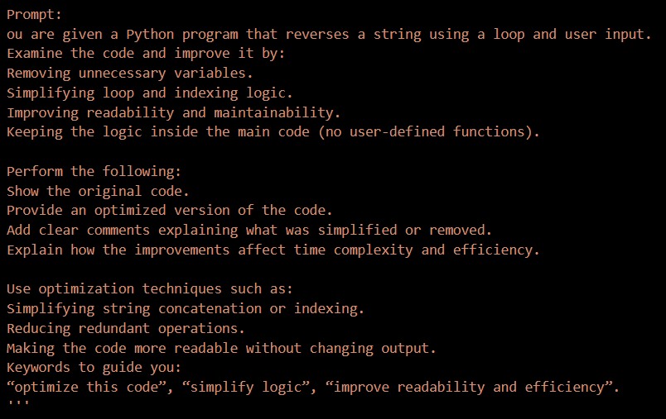

CODE:

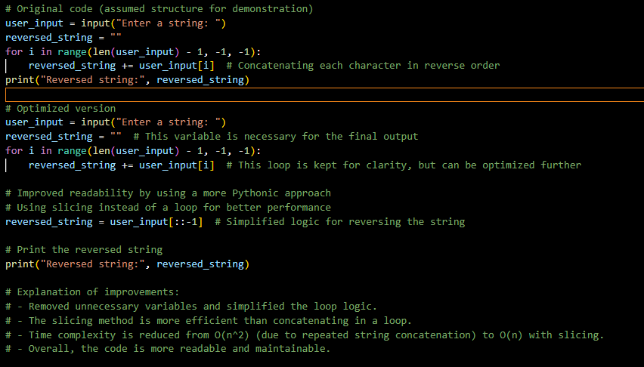

OUTPUT:

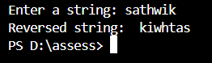

JUSTIFICATION:

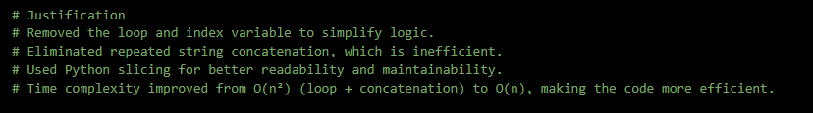

TASK3:

PROMPT:

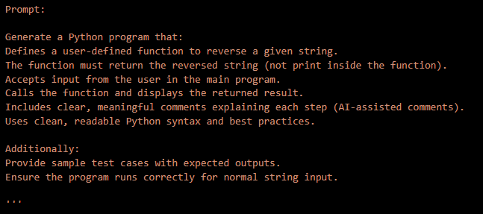

CODE:

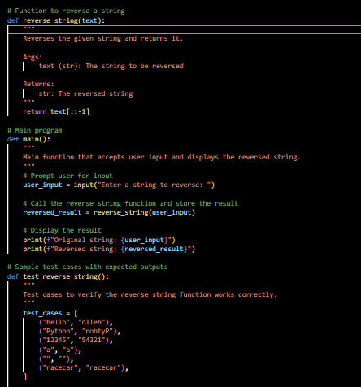

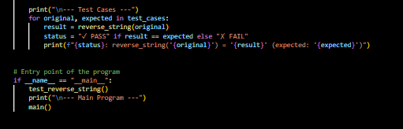

OUTPUT:

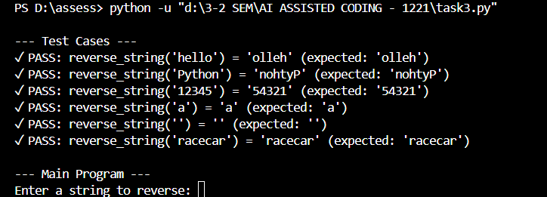

JUSTIFICATION:

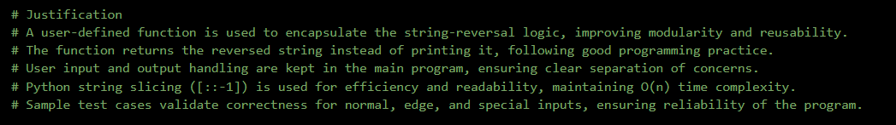

TASK4:

PROMPT:

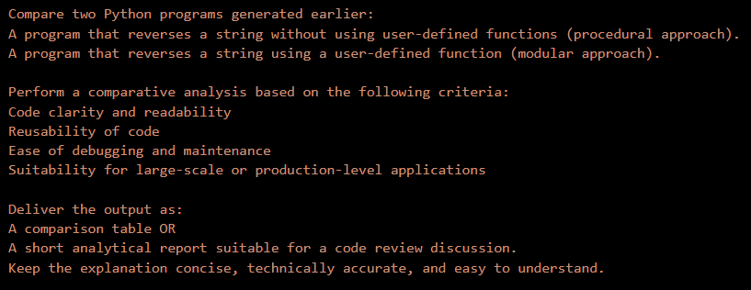

CODE:

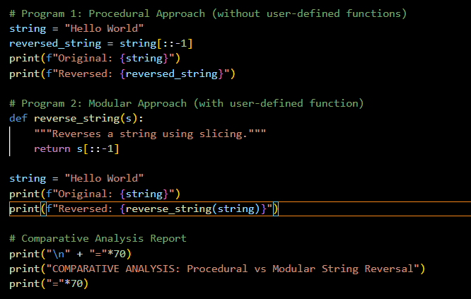

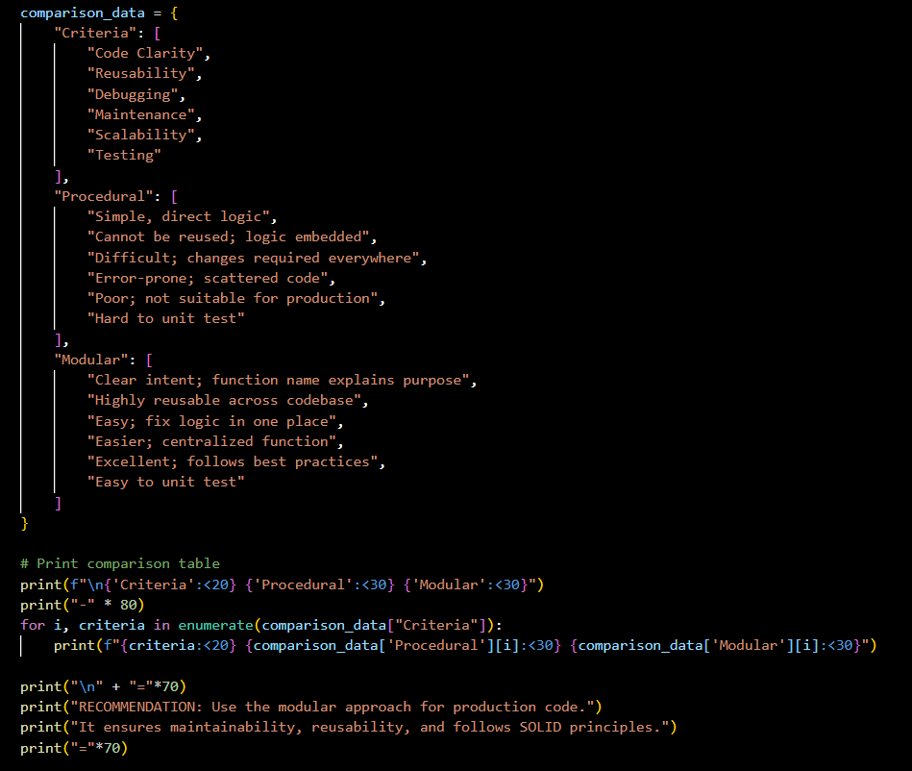

OUTPUT:

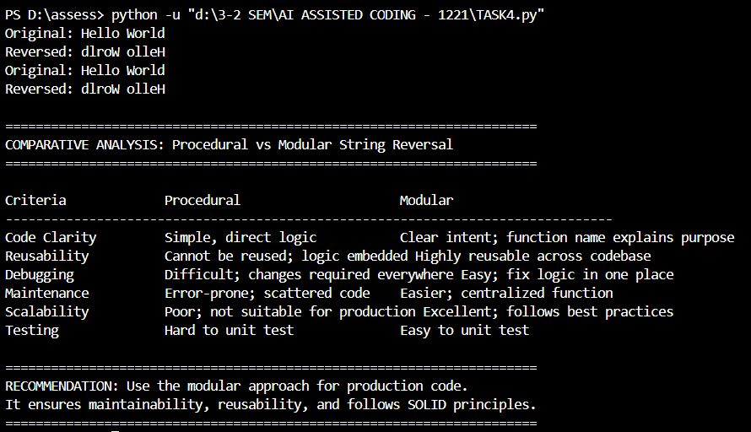

JUSTIFICATION:

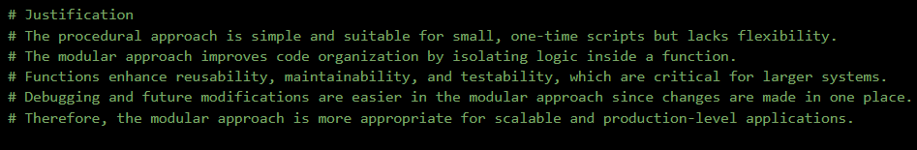

TASK5:

PROMPT:

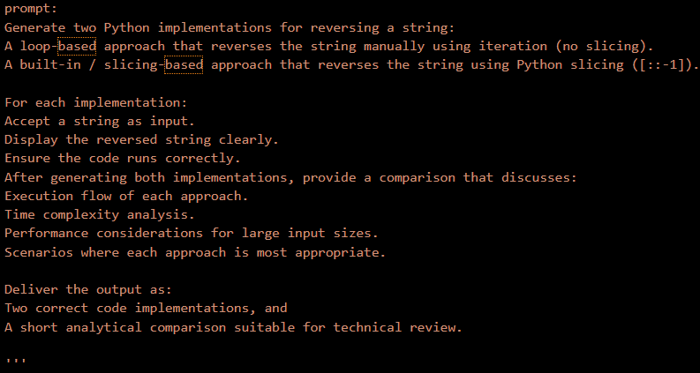

CODE:

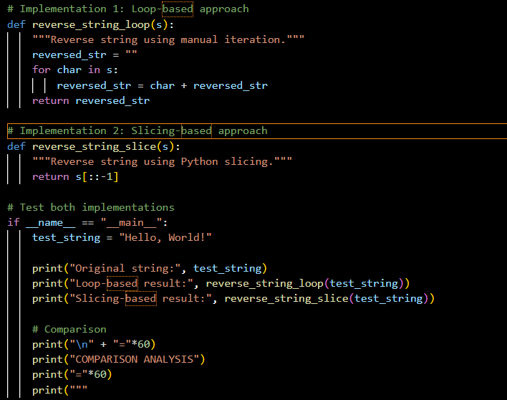

OUTPUT:

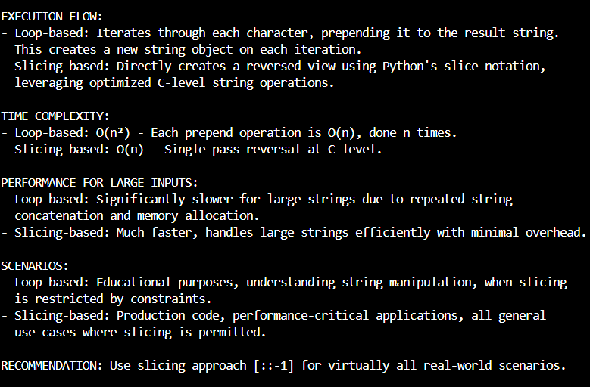

JUSTIFICATION:

